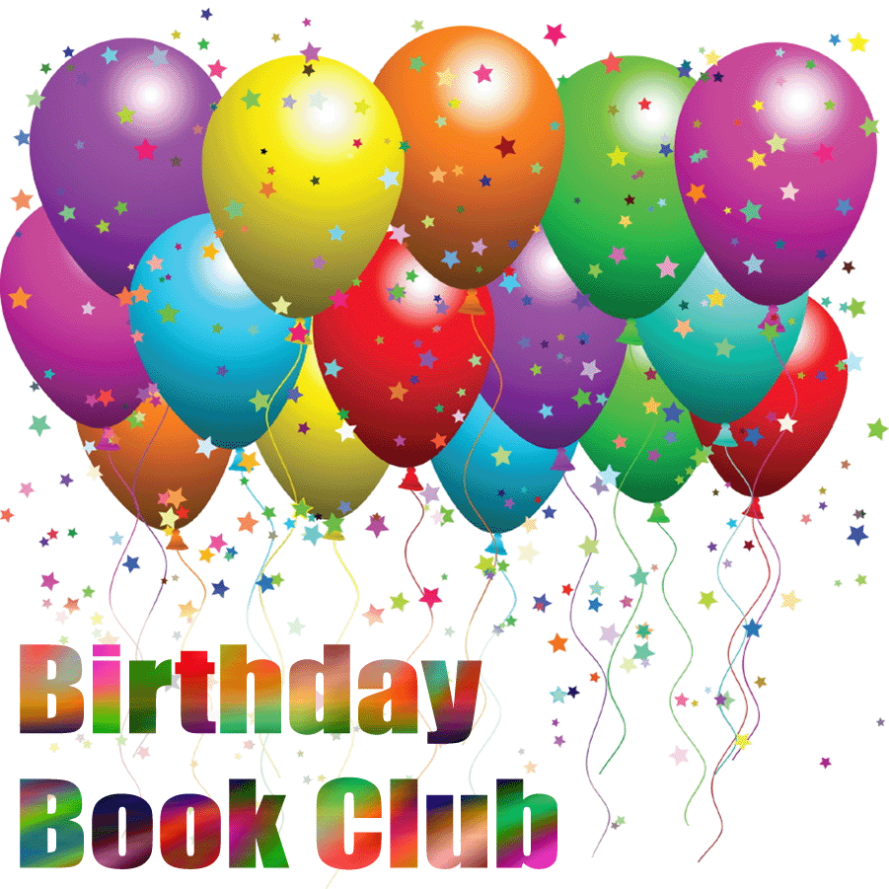

Celebrate your child’s birthday by joining the OLL Birthday Book Club! For a $20.00 donation, students will have the opportunity to choose a book from our special Birthday Book collection during the month of their birthday. A book plate will be placed in the book thanking your child and he or she will be the first to check out the book. When the book is returned, it will be placed into circulation for others to enjoy. This is a wonderful way to celebrate your child’s birthday while helping the OLL Library purchase great new books. Students with summer birthdays will choose their books during the school year. The Birthday Book Club and the Scholastic Book Fair are the main sources of funds for the Library. Your contribution of $20 (or more!) is greatly appreciated.
Please return this form along with a check for $20 per child made payable to OLL – PTG.

Name:____________________________Grade__________Birthdate_____________________Amount_________

Name:____________________________Grade__________Birthdate_____________________Amount_________

Name:____________________________Grade__________Birthdate_____________________Amount_________

